6.170 Team se042
Final Project: Gizmoball David Tsai
Ragu Vijaykumar
Eric Tung

Meeting Agenda: 4/24/03

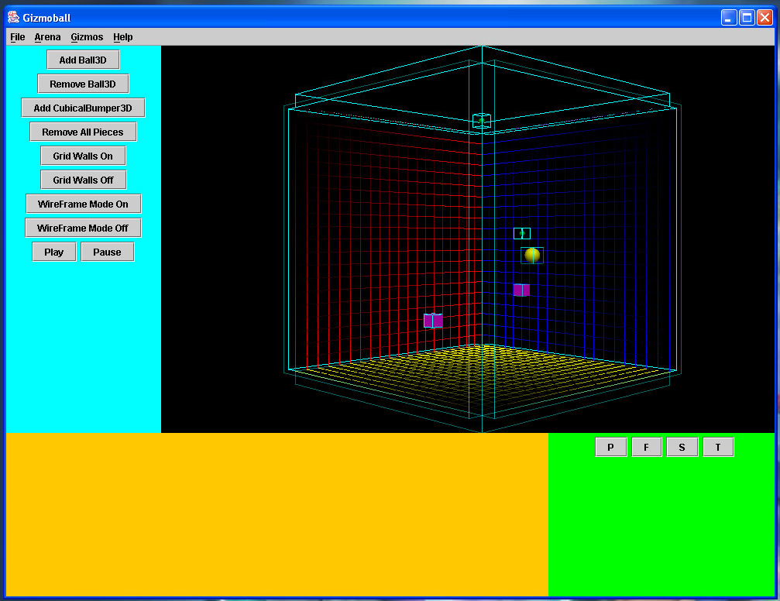
(screenshot from 4/21/03)

Progress since last week
A. Features implemented and issues solved
a. GUI
i. Cleaned up ball and gizmo code
ii. Interfaces and factory methods written up for gizmos
iii. Gizmos completed: Ball3D,
CubicalBumper3D (and Outer Walls),
SphericalBumper3D
iv. Play/Pause now works smoothly
v. Texture mapping now possible (e.g. Earth jpg around sphere)
b. Backend
i. Engine version 1 Completed
ii. “Beta Engine” #2 Completed
ii. “Celeron Engine” Completed
iv. “Pentium Engine” currently being worked on.
c. Physics
i. Basic physics functionality implemented
ii. Optimizations to physics
B. Bugs that were fixed
a. Several. Discuss at meeting.
C. Newly resolved design issues
a. Decided to move gizmo physics interfaces to backend.physics.
b. Decided to have counterpart gizmo interfaces in backend.graphics.
c. Factory methods now produce all gizmoball game pieces
d. All Piece graphic appearance properties moved to gui.PieceProperties

Description of new issues that have been discovered in the past week
A. Newly discovered bugs and problems
i. Too many balls (100+) lag the system
ii. Super-high velocity balls (~1350 L/sec) crash the system
iii. An issue with super high coefficients of reflections crashing the system.
iv. An issue with the engine crashing due to min. time decreasing by too
small amounts, therefore taking an extremely long time to exit out of
the physics loop.
B. Unresolved design issues
i. The 2D layout of GUI.
ii. Engine continuing to get modified
iii. Parsing/unparsing of gizmo data for load/save

Assessment of success of last weeks’ plan
- MILESTONE MET: Bouncing ball!!!
- A lot of progress made over the long weekend.
Integration of the three major modules successful.
C. Play/Pause works, as do the gizmos listed in A.a.

Plan for upcoming week
- Finish rotatable physics
- Start and finish flippers and absorbers
- Implement load/save
- Implement triggers
- Meet all requirements for 4/29/03 Preliminary Release

